Blockchain in the Sports Industry

Blockchain: the impact of fan-token and Chiliz (socios.com) and others in the sports Industry

**VERGNOLLE Thomas**

**Executive Summary**

This case study focuses on the impact of blockchain and the implementation of fan-token (cryptocurrencies dedicated to speculating on a professional club) in the professional sports industry. We will examine a real application of blockchain in the sports industry through an analysis of the mobile application Socios.com. This case study aims to highlight the different applications of blockchain in the sports industry by the company Socios.com, especially in the transparency of financial transactions or fan engagement.

Further analysis and study of this environment must be done to better understand the current state, the controversies but also the benefits that can be derived. Therefore, this case study will provide a better understanding of the concept of blockchain, sports marketing and fan-engagement with the support of studies conducted by researchers and authors, as well as their benefits, controversies and challenges identified on this topic.

We will examine a real application of blockchain in the sports industry through an analysis of the mobile application Socios.com.

**Table of Abbreviations**

|  |  |
| --- | --- |
| Abbreviations | Meanings |
| Crypto | cryptocurrency |
| HODL | Hold (a token) |
| CHZ | Chiliz token |
| PSG | Paris-Saint-Germain |
|  |  |

# 

# Table of Contents

Table of Contents 4

Introduction 5

Literature Review 7

Method 9

Data Analysis & Discussion 11

Conclusion 13

References 15

Appendix 17

# Introduction

Cryptocurrencies intrigue, fascinate, excite, and unleash crowds. The creation of Bitcoin (2008). and the blockchain has enabled much in the way of business, technology, and finance. There are many uses, and the commercial and financial applications have been growing steadily in recent years. Other uses of blockchain and cryptocurrencies can also be found in sectors such as agribusiness (Antonucci et al.,2019), medicine (Angraal et al., 2017) or even logistics (Chen et al., 2018).

In this case study we will look at the use case of blockchain in sports. Indeed, the sports industry has not escaped the implementation of blockchain and has taken advantage of it to bring new practices, transparency, and economic benefits. There are several segments in which blockchain has been able to establish itself in a sustainable and efficient way (team/club/league/federation management..., health and sports medicine, doping, physical preparation, sports betting, fantasy leagues, collectibles...). However, the segment that has been able to make its mark so far is that of fan engagement, which aims to give the fan a prominent place in the club, involve the fan in the management of the club and generate revenue. Socios.com (or Chiliz) is spearheading this industry. Founded by Alexandre Dreyfus (2019), this company aims to market fan tokens to allow fans to speculate and support a club, all based on Chiliz (CHZ), the exclusive cryptocurrencies of the Chiliz platform.

The so-called fan tokens are utility tokens. In the crypto world, this refers to tokens that allow the holder to benefit from certain advantages (physical or virtual), rewards (monetary or non-monetary) or even voting and governance rights in certain protocols. In this case, with the CHZ, the holder of a fan token has many rights and duties towards the team designated by his token. He can thus participate in the choice of the team's jersey, the choice of a player's presence for a particular event or have a say in the recruitment. There are also commercial benefits such as discounts on team merchandising, tickets for games, the possibility to win VIP experiences... Fan tokens are fungible in nature unlike NFTs which are non-fungible.

Socios.com has become a major player in the blockchain ecosystem in the sports industry. Indeed, the popularity of the app and the CHZ has literally exploded in the last two years. The $CHZ has a valuation in February 2022 of $1,179,130,219 (CoinMarketCap.com) for a price of $0.1974 (the token has increased by more than 10,000% in 3 years). The list of Socios.com partners and affiliated clubs/leagues continues to grow and reflects the democratization of fan tokens. There are many soccer clubs such as PSG or FC Barcelona, NBA clubs, the mixed martial arts league (UFC), Formula 1 and even e-sports. The popularity of fan tokens extends beyond the borders of each sport and interests all sports entities today. Thus, all sports fans can be potential targets and users of fan tokens regardless of the sport. The potential growth of fan token is therefore exponential. The CHZ digital asset is therefore potentially bound to last and increase in value. So, what are the basics, benefits and use cases of fan tokens from Socios.com?

On the other hand, it is important to note that the volatility of cryptocurrencies, the lack of hindsight and knowledge on the impact of these financial derivatives raise unanswered questions. Is speculation on fan tokens risk-free?

Criticism and doubts about the crypto-currency sector are numerous and very virulent. Fan tokens have not escaped this. It is then imperative for the big financial authorities to regulate all this because the drifts and risks are numerous. How to regulate the use of fan tokens without altering their functioning?

The remainder of this document is constructed as follows: Literature Review, Conclusion and References.

# Literature Review

In this case study we will study through the literature, fan engagement and mass adoption of fan tokens.

The amount of fan tokens present on the market is limited. This is a very important aspect of cryptocurrencies which unlike fiat money cannot be printed in unlimited quantities (Bitcoin is limited to 21 million tokens). It is therefore by relying on this characteristic of scarcity that Socios.com to create fan tokens indexed on the CHZ and professional clubs. The main objective is to create monetization through engagement (act of purchase and hodl). This is what Cedric Dufour explains here: *"The key to this success is the right mix of value, unique offers and exclusive features for consumers. Thanks to the partnership with Chiliz and Socios.com, we are now the only loyalty program to integrate the possibility of redeeming points for tokens".*

*Table 1. Price action of $CHZ (Chiliz token from socios.com)*

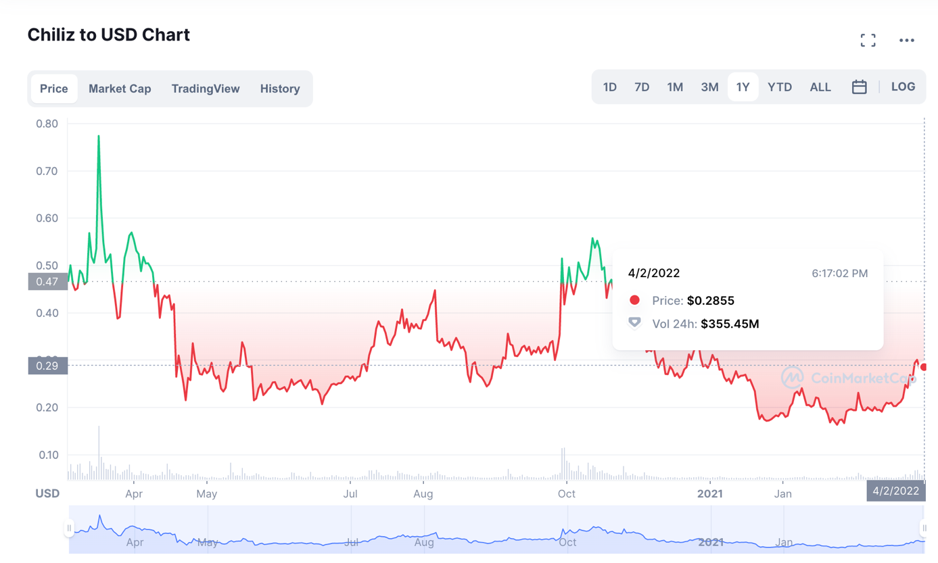

Next, we will focus our literary review on the different aspects of fan engagement and the different use cases of fan tokens:

Many may think that crypto currencies are only useful for speculation. However, many crypto-assets are utility-token and have a real utility in the real world (virtually sometimes). This is the case with fan tokens which can be used in many ways.

*"So, the only thing that can develop in the sports industry is fan monetization. But what can you sell to a fan? There's always this dream of, oh, we're going to sell content, and they're going to have backstage. Nobody buys that. The only content people buy in sports is live sports; that's it."* Alexandre Dreyfus, 2020.

One of the key aspects of fan tokens is to give meaning back to fans' affiliation with a given club. Hodl a fan token can be purely speculative but also for sentimental reasons. One of the uses of fan tokens is the right to vote, just like a company share. Fan tokens give fans control over the management of certain aspects of the club. (Matthias Scharnowski, 2021). As discussed by A. Dreyfus *"Socios.com is above all a voting platform for sports fans". As for blockchain, it allows for transparency and decentralization of power, as the latter states, supported by his colleague C. Dufour also* "Blockchain was the most practical and eloquent way to unite the need to maintain the integrity of votes while transforming voting rights into a *"possessable" commodity, in our case a token".*

Finally, it is towards regulation that this literary study is directed.

Regulation is a very delicate issue for the crypto-asset market. Socios.com chose to first propose the purchase of fan tokens via their own application Chiliz which allowed to centralize the purchases and the cash. In a second step, some tokens were listed on different centralized exchanges like Binance, a crypto exchange. Thus, the regulation on speculation is intrinsically linked to national and international laws on speculation of financial assets. (Vidal-Tomás David, 2022).

# Method

In this case study, both primary and secondary data were used. We essentially proceeded to study these data with a deductive approach

Firstly, the study of Matthias Scharnowski, Stefan Scharnowski, Lukas Zimmermanna (2021) & the report of Vidal-Tomás, David, (2022) were used to understand the implementation of fan tokens in the world of sports.

Second, we conducted a study with a questionnaire. This questionnaire was made with a mono method to collect quantitative and qualitative data. The purpose of this questionnaire was to find out if these men, sportsmen, know the marketing practices of the sports sector, the fan-engagement, and the fan tokens. The first questions of this study aim to identify the knowledge of sports marketing and the democratization of fan tokens. Questions 4) and 5) help to understand whether these consumers are for or against the implementation of crypto currencies in the sports sector and whether they are inclined to adopt them themselves in their daily lives as sportsmen/supporters. The sixth question is a question about the financial regulation of crypto-currencies in sports and is complemented by an open-ended question about their opinions towards the regulation and centralized control of crypto-currencies in the world of sports.

*Table 2. Question’s table of the survey.*

|  |  |  |
| --- | --- | --- |
| **Number** | **Questions** | **Response Format** |
| Q1 | Are you familiar with the following practices in sports marketing (Sponsorship, Naming, Merchandising, Advertising and Product Placement...)? | multiple choice grid |
| Q2 | Have you ever heard of fan tokens? | checkbox |
| Q3 | Have you ever bought a fan token? | checkbox |
| Q4 | Do you think fan engagement can have a financial/specular aspect? | dropdown |
| Q5 | Do you think fan tokens are a win/win for fans and clubs? Why? | dropdown + open answer |
| Q6 | Should fan tokens be owned by the clubs/centralized platform? | checkbox |
| Q7 | If companies that hold and administer fan tokens, they can manipulate the market. What do you think about this? | open answer |

# Data Analysis & Discussion

We will now present the results of our pilot study and our analysis of them.

Our sample of respondents is composed of men between 20 and 38 years old. The majority are between 20 and 24 years old (61%), followed by those between 32 and 38 years old (39%). 100% of the participants are men. 78% of them are athletes. They are either students or professionals who work in the sports industry (hospitality and sports marketing agencies or professional clubs).

The purpose of this data analysis collected via the study of Matthias Scharnowski, Stefan Scharnowski , Lukas Zimmermanna (2021) is to try to understand the functioning and contribution of fan tokens in the acquisition strategy of a club. We are talking here about acquisition and retention of fan/supporter but also of partners, players, and companies/investors.

To do this, the fifth question of my survey asked respondents to express their opinion on fan tokens and what they could bring to clubs and fans. According to them, the first purpose of fan tokens is financial speculation. The second element that comes up most often in the participants' answers is the "marketing" aspect. According to them, fan tokens have a purely marketing purpose for clubs, who are only looking to take advantage of the trend to offer a new product to consumers and generate a new source of revenue. Finally, the last element that came up 6 times in the participants' answers is the payment of professional players in fan token (the case of Messi at PSG for example).

Then, the results of the rest of the survey reveal that the participants have a good knowledge of the sport environment and the business that surrounds it. Moreover, more than 75% of them have already heard about or bought fan tokens, which proves that the democratization of this kind of financial product is on the way.

Finally, it is interesting to look at the issue of regulation. The open-ended answers to the last question of the survey allow us to compare the current regulation, mentioned by Vidal-Tomás, David, (2022) in his report, with consumers' expectations.

The answers given by the participants in the survey correlate with the current regulation and the questions about the risks of a centralized system are legitimate. In the study by Vidal-Tomás, David, (2022), it is noted that the reliance on a centralized system provides certain financial guarantees to fan token buyers and speculators. On the other hand, the risks are always present since a single entity holds the money and can be subject to banking variations, governmental or institutional pressures or even manipulate the price of a token via its own treasury on external exchanges (Binance.com or Uniswap to name but two).

In addition, the sixth question in which we asked respondents whether fan tokens should be held and traded via a centralized exchange received only 51% favorable responses. As Matthias Scharnowski, Stefan Scharnowski, Lukas Zimmermanna (2021) report, it is possible to exchange money for fan tokens on semi-centralized exchanges such as Uniswap and on external exchanges such as socios.com. So, to date, you should mainly trust the centralized exchanges if you want to adopt a fan token. Finally, to enjoy the physical and digital benefits of these "utility tokens" it is imperative to use the socios.com platform and store them there. The user is then exposed to several risks, financial variations or "hack" of the platform, data theft...

If we trust the answers obtained during our survey, we could think that the fan engagement will be revolutionized by the fan token. Indeed, sportsmen and fans seem to be very favorable to the adoption of cryptocurrencies in the sports world. The naming of stadiums like "Crypto.com Arena" in Los Angeles, proves that cryptocurrency companies are already present in sports and in a very powerful way. They are taking advantage of sports marketing to democratize themselves among consumers. During the superbowl, 3 cryptocurrency companies including Coinbase were able to enjoy a commercial. In addition to the ubiquity of these companies through sports, the public seems receptive and playful by their adoption.

Fan Tokens allow their holders to enjoy physical and digital benefits such as the possibility to buy tickets for a game or merchandising of your favorite team directly with this digital currency. These utility tokens also allow their holders to be rewarded with VIP experiences, jerseys, corporate events or to enjoy a voting right in the running of the club. Although this is their primary use, it is not what interested the fan token buyers we interviewed. The lack of education about crypto-currencies and the lure of financial gain and speculation means that some people buy fan tokens to make a profit. They choose these tokens rather than another because the sporting aspect reassures them.

# 

# Conclusion

In studying the implementation of blockchain to the sports industry, we became aware of the role of socios.com and fan tokens in fan engagement. (Broustail 2022) (Dreyfus, 2020).

We studied the different aspects of fan engagement enabled by blockchain and socios.com (Scharnowski, 2021), and discovered the different promises of fan tokens... (Dreyfus & Dufour, 2020)

Finally, we have seen the difficulties related to the regulation of crypto-assets (Vidal-Tomás David, 2022), and we have glimpsed the advantages of centralized platforms like Chiliz or Binance. This literature review therefore links the use of fan tokens by carriers for different reasons and studies a particular use case of the blockchain.

We will then investigate whether it is possible to use the CHZ blockchain for purposes other than speculative and commitment purposes, what are its limitations and what are the drifts for regulation.

# References

A. Broustail, Blockchain EZ, (2022, December). Cryptoactifs : « Le concept du “fan token” semble promis à un bel avenir ». News Tank Football. <https://football.newstank.eu/article/view/201032/cryptoactifs-concept-fan-token-semble-promis-bel-avenir-broustail.html>

Vidal-Tomás, David, (2022, January) Blockchain, sport and fan token. 3-5 <https://mpra.ub.uni-muenchen.de/111350/>

Front Office Sports - Sports Business News. (2021, December). Socios.com: A Case Study in Blockchain Applications for Sports. Front Office Sports. <https://frontofficesports.com/insights/socios-a-case-study-in-blockchain-applications-for-sports/>

Appel, G., Grewal, L., Hadi, R., & Stephen, A. T. (2020). The future of social media in marketing. Journal of the Academy of Marketing Science, 48(1), 79-95.

Ivan. (2020, March). What is Chiliz, Socios, and the CHZ Token? Academy Moralis. <https://academy.moralis.io/blog/what-is-chiliz-socios-and-the-chz-token>

S. McCaskill, (2018, September). Can Blockchain Give Fans A Meaningful Say In How Soccer Clubs Are Run? Forbes <https://www.forbes.com/sites/stevemccaskill/2018/09/12/can-blockchain-give-fans-a-meaningful-say-in-how-soccer-clubs-are-run/?sh=4759b232b83c>

Matthias Scharnowski, Stefan Scharnowski , Lukas Zimmermanna, (2021 December) Fan Tokens: Sports and Speculation on the Blockchain? 3-12 <https://papers.ssrn.com/sol3/papers.cfm?abstract_id=3992430>

Usman K. Shuja. (2020, December). The Game Day Experience – Now What? Forbes <https://www.forbes.com/sites/honeywell/2020/12/10/the-game-day-experience--now-what/?sh=24e5cb1a55c5>

T. Wojciak. (2019, January). Blockchain : le PSG conclut un partenariat avec socios.com CBNews. <https://www.cbnews.fr/marques/image-blockchain-psg-conclut-partenariat-avec-socioscom-38565>

# Appendix

1. Fan Token listed on Chiliz App

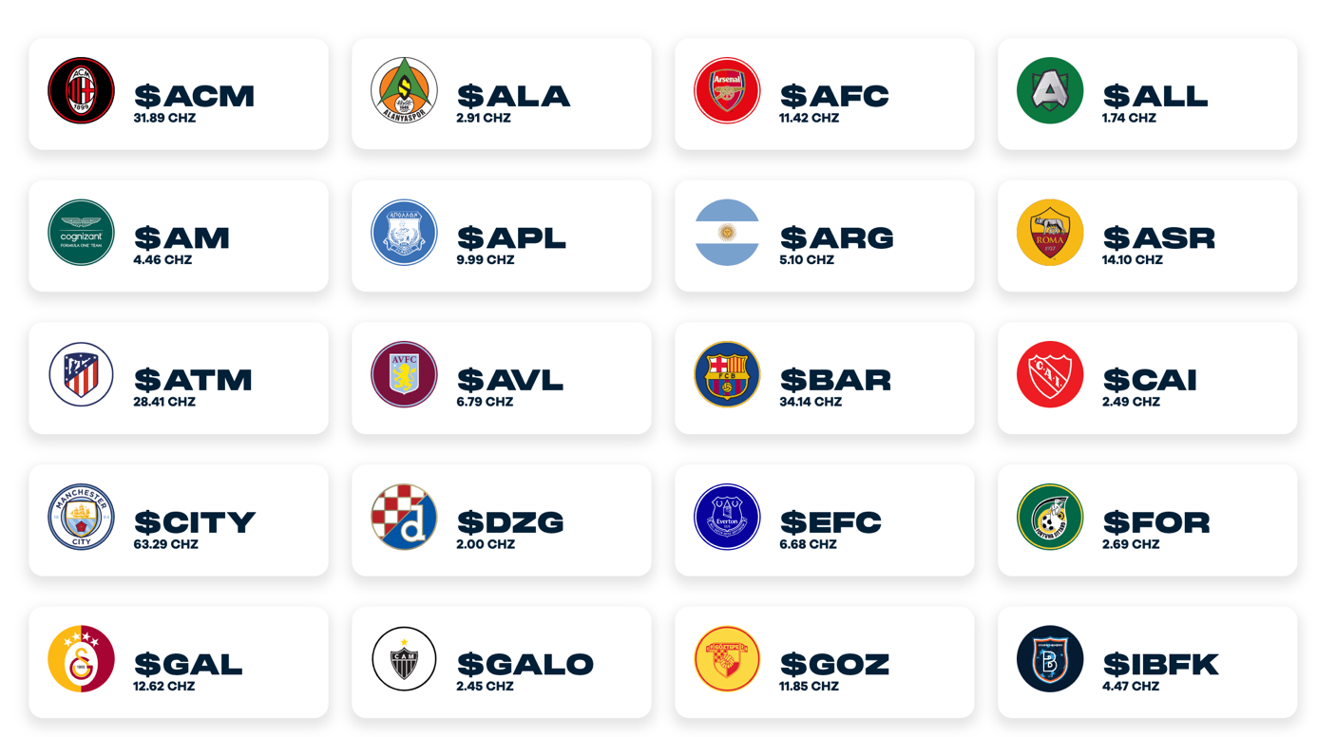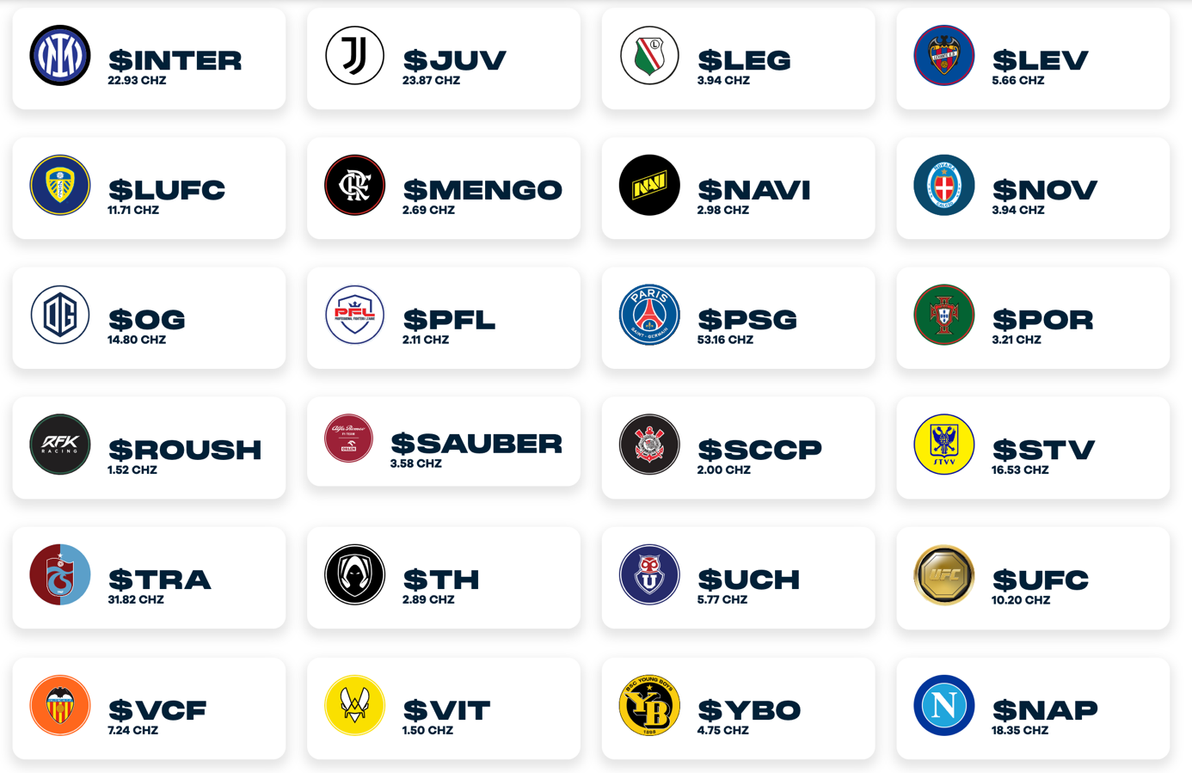

1. Answers of the survey

